Isokon (1931-39)
Michael Johnson, Northumbria University
Isokon was a British furniture and architectural design company founded in London in 1931. Led by architect Wells Coates and plywood manufacturer Jack Pritchard, Isokon was among the first systematic attempts to introduce modernist design to Britain. The founders of Isokon were committed to the principles of European modernism and aimed to create standardised housing and furniture based on modern materials and production processes. In interwar Britain, these designs represented radical new solutions for modern living.
Jack Pritchard joined the Venesta Plywood Company in 1925. At this time plywood was regarded as a cheap substitute for solid wood, but Pritchard was intrigued by its intrinsic properties of lightness, fluidity and strength, and was keen to promote it as a material for modern design. In 1929 he encountered the work of Canadian-born designer Wells Coates, who had recently created innovative plywood factory interiors and shop-fittings for Cresta, a silk manufacturer. Pritchard and Coates founded the firm of Wells Coates and Partners in 1930 to facilitate collaboration. Tensions between the two prompted reorganisation, however, and the firm of Isokon Limited was founded on 31 December 1931. The name was derived from the term Isometric Unit Construction, owing to Coates’s preference for isometric drawing.
A company memo of March 1932 listed Isokon’s aims thus: to use standardisation, new materials, moveable partition walls, ribbon windows and integrated furniture. Houses were to be built on the principle of standardised units, allowing interior equipment to be fitted ‘into any shell that the Company may build’ (Isokon, company memo of March 1932). The directors of the company were Pritchard’s wife Molly, a bacteriologist, the solicitor Frederick Graham-Maw, and the economist Robert S. Spicer. In practice, however, the company was run by Pritchard, who hired designers to create the product range and oversaw the marketing.
Isokon’s core principles were realised in its first major project, the design and construction of Lawn Road Flats in Hampstead (1933-34). The Pritchards commissioned Coates to design a block of flats based on Le Corbusier’s concept of the minimum dwelling. Coates designed a pristine white edifice with graceful cantilevered access decks. Aimed at young professionals, the block contained 22 single flats, four double flats and three studio flats, plus staff quarters, kitchens and a garage.
The interiors reflected Coates’s ideal of a rigorous, frugal lifestyle unencumbered by possessions, which was in part derived from the concept of Existenz-minimum (minimal living) developed at the Congrès internationaux d'architecture moderne (CIAM) in 1929. Built-in furniture included a sliding table, armchair, radio and divan. The aesthetic was minimalist throughout, and made much use of plywood. A beacon of modernist ideals, the building became a haven for designers fleeing oppression in Nazi Germany. Walter Gropius, the former principal of the Bauhaus, arrived in London in Autumn 1934 and took up residence at Lawn Road Flats, followed by Marcel Breuer.
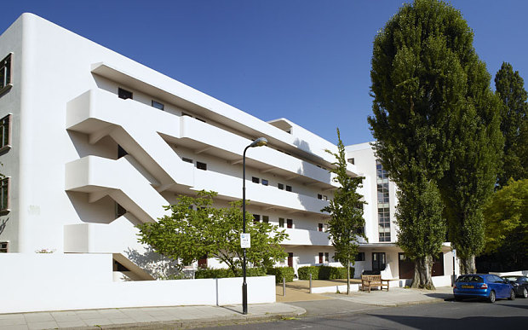
Wells Coats, Lawn Road Flats, London (1934) http://i.telegraph.co.uk/multimedia/archive/03022/summary_3022871b.jpg
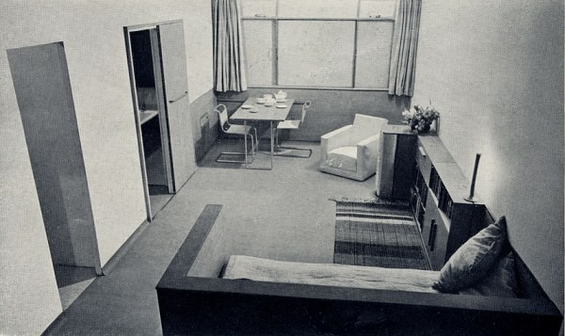
Wells Coats, minimalist apartment at Lawn Road Flats, London (1934)
http://images.adsttc.com/media/images/5244/93d3/e8e4/4e67/bf00/0161/large_jpg/isokon_minimum_flat.jpg?1380225998
Isokon commissioned designs from leading exponents of modernism, initially to provide furniture for Lawn Road Flats, but with the long-term aim of transforming the standard of design within the British home. Coates designed a book unit in 1933, as well as a desk made from the same units. Gropius was appointed Controller of Design for Isokon in October 1935. When he departed for the USA March 1937, he recommended the former Bauhaus student Marcel Breuer as his replacement.
Breuer was eager to continue his experiments with tubular steel furniture, but Pritchard advised him that the British were too conservative to buy metal furniture. Instead, Breuer worked in Pritchard’s favoured material, plywood, creating five notable pieces in which the material was used in a highly fluid manner. These included a nest of tables, in which each table is formed from a single sheet of plywood, and a Long Chair, which has an undulating seat and wave-like arm rests. These pieces perhaps reveal the influence of Alvar Aalto, who developed a more organic approach to modernism using moulded wood, but they were also influential in their own right. In 1937 Breuer designed a restaurant and bar (the Isobar) as an addition to the communal facilities at Lawn Road Flats, which became a centre of intellectual life in London.
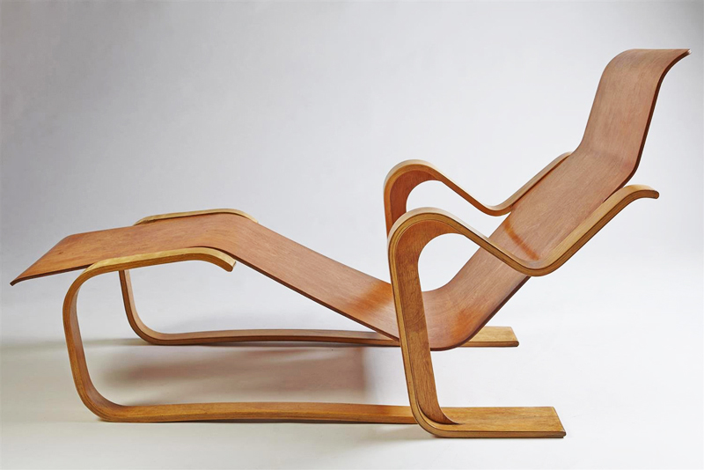
Marcel Breuer, Long Chair (1936)
http://41.media.tumblr.com/75ddca3e29f8b666da471ef01f9878b9/tumblr_mzntl5qitd1rpgpe2o1_1280.jpg
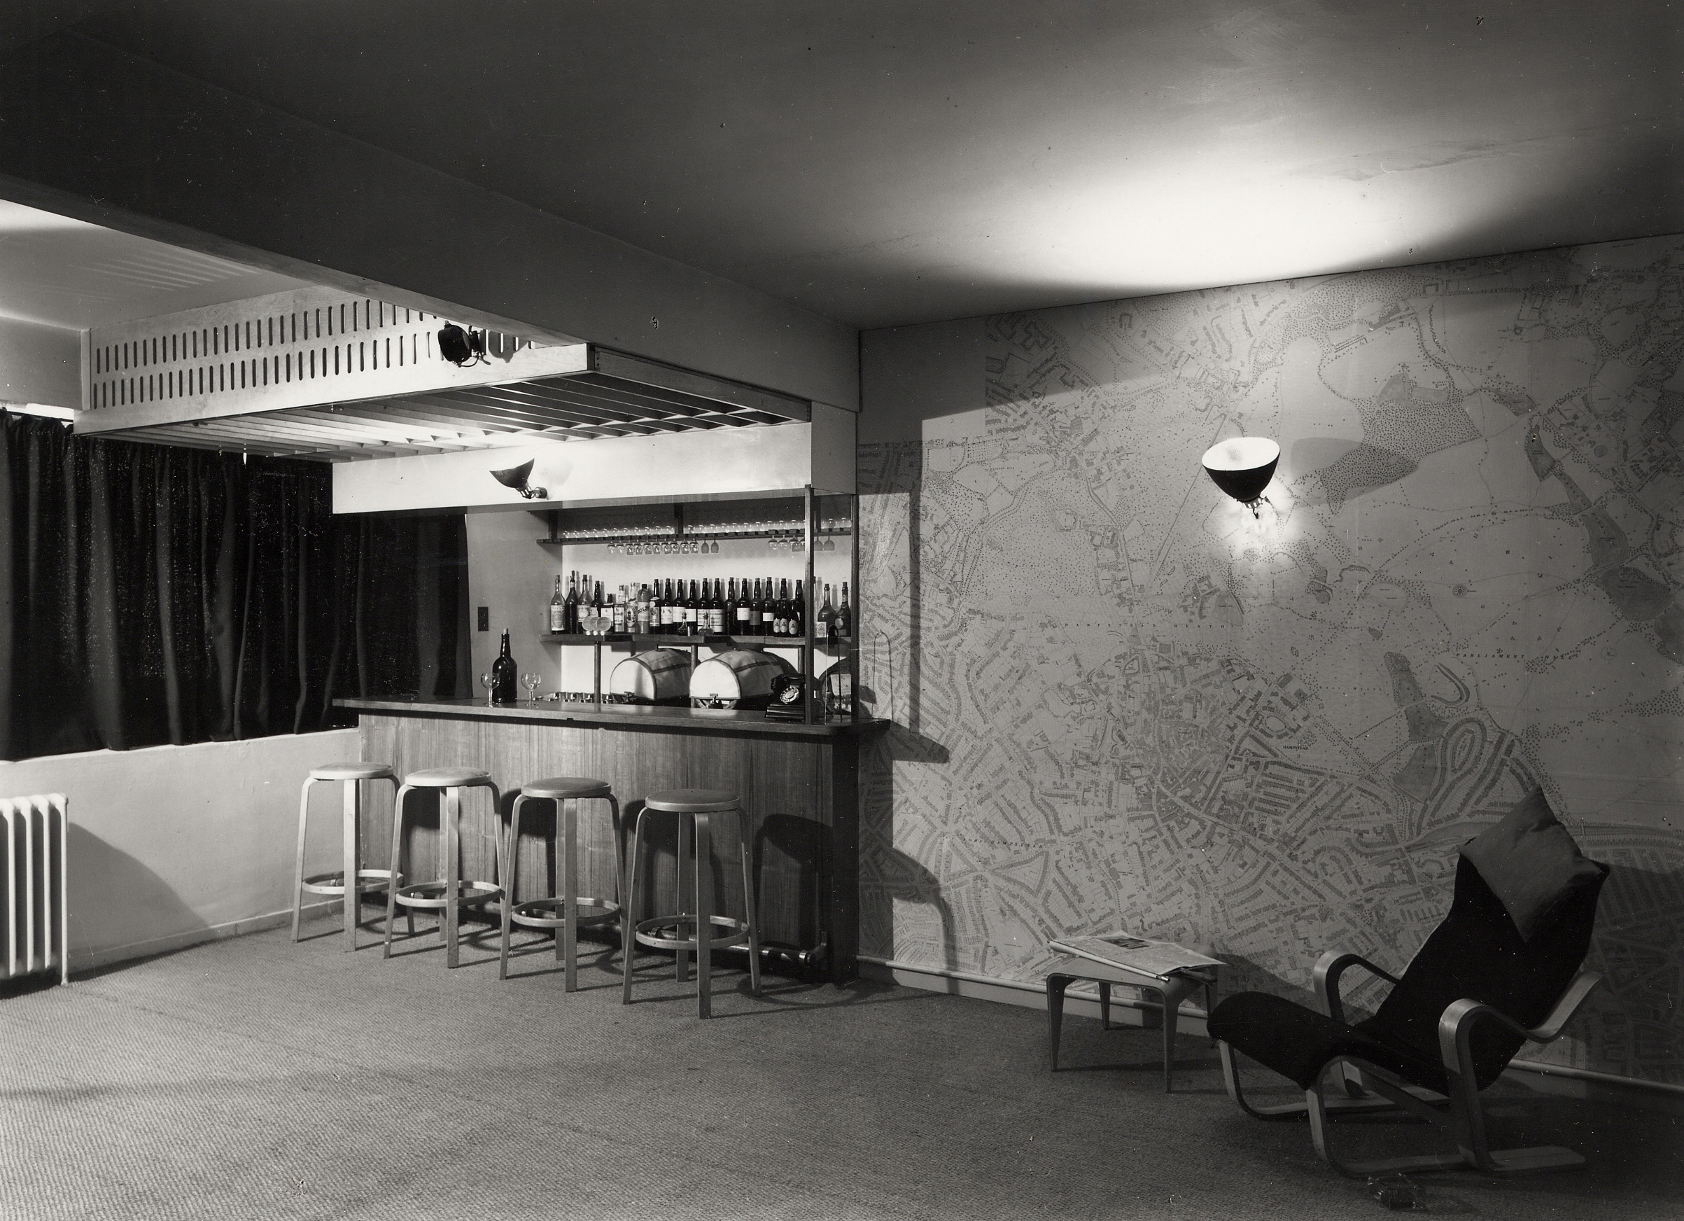
Marcel Breuer, Isobar restaurant at Lawn Road Flats (1937)
https://taguealibrary.files.wordpress.com/2012/03/pp-17-5-18-carchitecturalreviewexpired.jpg
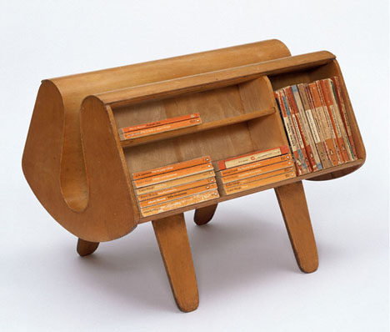
Egon Riss, Penguin Donkey (1939)
http://s3files.core77.com/blog/images/2012/05/0penguindonkey01.jpg
A notable Isokon product was a bookstand designed by Austrian émigré Egon Riss, which resembled saddlebags slung over a donkey’s back. Known as the Penguin Donkey, this was marketed via sales leaflets inserted into the inexpensive paperback books published by Penguin, which helped to democratise knowledge in the interwar period and beyond. Isokon’s striking publicity material was designed by another Bauhaus émigré, László Moholy-Nagy, who arrived in Britain in May 1935. His sales leaflets featured innovative graphic designs, while his Isokon logo depicted a folded plywood chair.
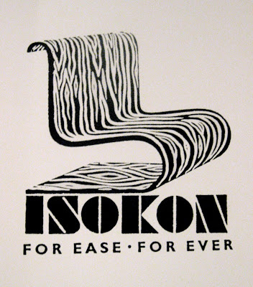
Lásló Moholy-Nagy, Isokon logo (c.1935)
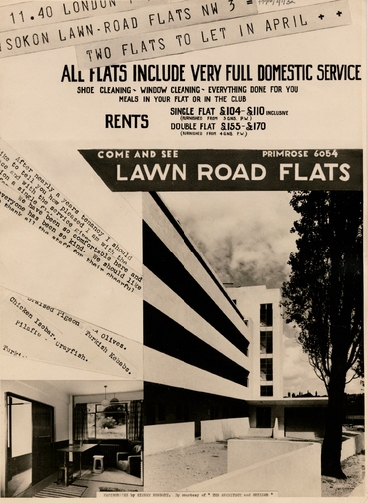
'Come and see Lawn Road Flats', design for advertisement (c.1934)
http://archiveshub.ac.uk/features/jun03c.shtml
Isokon was not a commercial success and its influence on the British domestic landscape was limited due to a lack of financial support and the difficulty of converting British consumers to modernist aesthetics. With the outbreak of World War II, Isokon’s supply of cheap plywood from Estonia was terminated and the firm ceased production in 1939. However, Pritchard revived the Isokon Furniture Company in 1963 and hired Ernest Race to produce new designs. In 1968, Pritchard licensed John Alan Designs to reproduce notable Isokon pieces, including Breuer’s Long Chair and Nesting Tables.
List of works
Wells Coates, Lawn Road Flats, Hampstead, London, 1933
Wells Coates, Book Units, 1933
Wells Coates, Desk made from Book Units, 1933
Walter Gropius, Aluminium Waste Paper Basket, 1935
Walter Gropius, Side Table GT2, 1936
Marcel Breuer, Nesting Tables, 1936
Marcel Breuer, Dining Table, 1936
Marcel Breuer, Stacking Chairs, 1936
Marcel Breuer, Long Chair, 1935-6
Egon Riss, Pocket Bottleship, 1939
Egon Riss, Penguin Donkey, 1939
Further reading
Buckley, C. (1980) Isokon: Architecture, Furniture and Graphic Design, 1931-1939. Newcastle: University of Newcastle.
Cantacuzino, S. (1978) Wells Coates – A Monograph. Gordon Fraser.
Cohn, L. (1979) Wells Coates: Architect & Designer, 1895-1955. Oxford Polytechnic Press.
Grieve, A. (2004) Isokon: For Ease, For Ever. London: Isokon Plus.

Pritchard, J. (1984) View from a Long Chair: the memoirs of Jack Pritchard. London: Routledge.

